Information about Participating in TIDE Lab Research Experiments

Researchers in the Culverhouse College of Business use a recruitment system called SONA to interact with participants. All studies taking place in The Interactive Decision Experiment (TIDE) Lab will recruit participants from this system. This guide will tell you all you need to know to register in SONA and begin participating in research experiments for cash or other incentives.
First, let’s go over a few things about experiments in the TIDE Lab.
- Can I participate in studies in TIDE Lab?

Anyone 18 and older can register for SONA and be added to the pool of participants. Some studies are looking for particular kinds of participants, however, so you may not be eligible for all of them.

- What types of studies are there?

Once you have registered in SONA, you will see a few different types of studies. These types are: studies for credit in a specific class at UA, studies for Gifts and Raffles, and Paid Studies.

Credit Studies
Some studies are course credit in specific classes. Be sure not to sign up for these studies unless you are in that class and your instructor has talked to you about doing so for class credit. After you sign up and complete the study, you will be awarded credit in that class for participation.

Gifts and Raffles
Studies under the category of Gifts and Raffles will compensate you by either giving you a fixed gift (this could be cash or a specific item like a gift card) or by entering you into a raffle for the chance to win a prize (like cash or a gift card). All that is required to receive the gift or be placed in the drawing is completion of the study. For a specific study you will be told exactly what the gift or raffle is.

Paid Studies
Studies under the category Paid Studies will compensate you with cash. However, unlike the Gifts and Raffle studies, your compensation will be based on what happens in the study. You will be given $5 for signing up for the study, showing up on time, and participating. You will also earn additional money in the experiment with the average being $10-$20 per hour.
- How do I know if there is a study I can participate in?

If you have a SONA account with TIDE Lab, you will receive emails from us about upcoming studies. If it is a study that you want to do then you can log into your account and register for the session if there is space. Space is limited and sign-up is first come first serve. If a session is full then it may not show up in your account.

- Where is TIDE Lab?

TIDE Lab is located on the second floor of Bidgood Hall (when you enter from the quad), in Bidgood 249.

- What do I do after I sign up for a study?

On the day of the study you signed up for, you must arrive at TIDE Lab at least 5 minutes early to check in. Failure to do so may make you unable to participate and thus not be compensated. Please sign in at the front desk and wait in the lobby until you are called into the lab.

- When will I be compensated?

For Paid Studies, you will be given the cash you earned immediately after the session is over. For studies involving a Raffle, you may have to wait for the Raffle to occur before being compensated, but this will be maide clear to you when registering fro a session. .

- Can I participate in more than one study?

You may sign up for as many studies as you like as long as you are eligible for the study, but you may only participate in any single study once. In general, you will not be able to see studies for which you are not eligible, but there may be specific criteria mentioned in the recruitment email. For example, a study may only be open to seniors.

Registering in SONA

To register in SONA, first go to the Culverhouse SONA website:

https://culverhouse.sona-systems.com/

Once there, click the Request Account button.

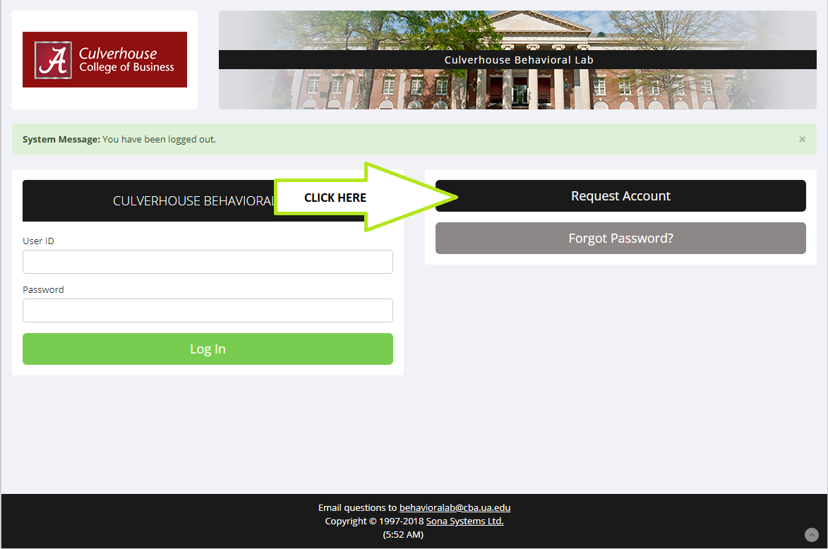

Next, you will need to fill out some information and request an account. At the bottom of this screen, you will be asked to select a course. These courses are the different types of studies. Please select all types of studies you are interested in seeing. Note: Please do not select a course designated for a specific class unless you are in that class. You will not be given cash as compensation for those studies. 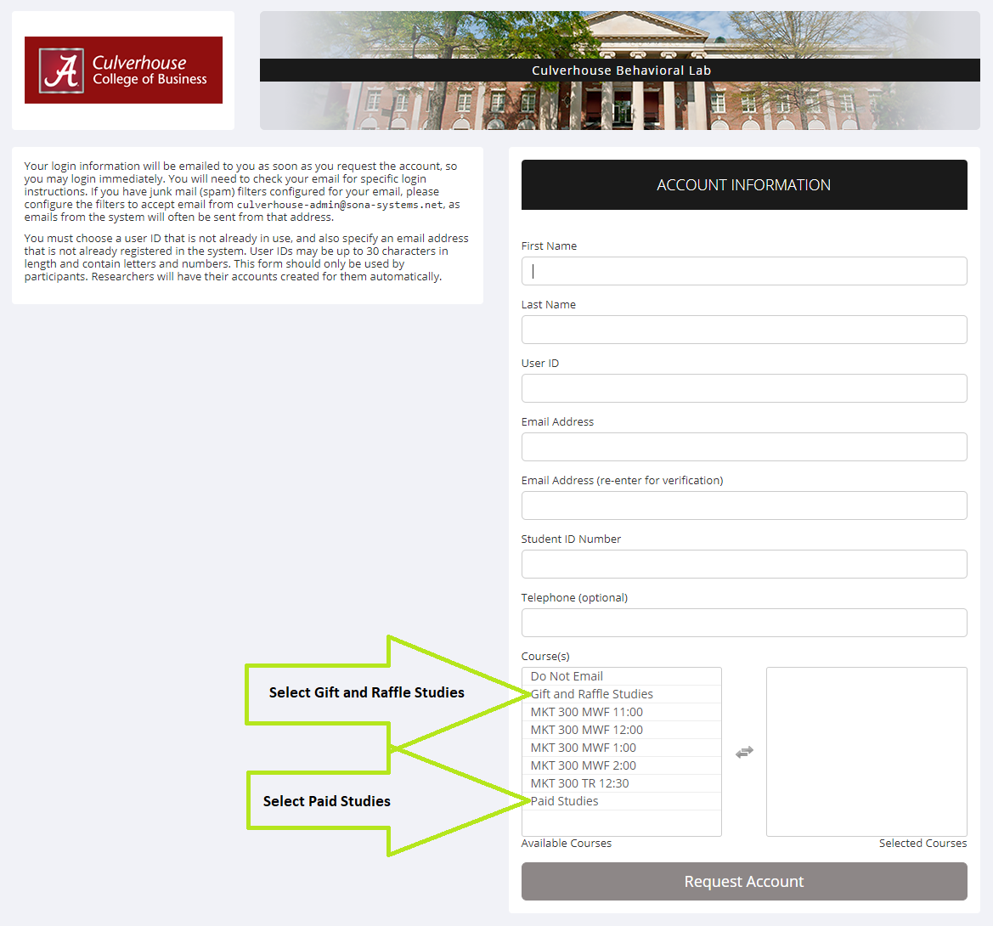

Signing up for Studies

After you have registered, you will receive an email with your password. To sign up for a study, sign into SONA and click on the View Available Studies button.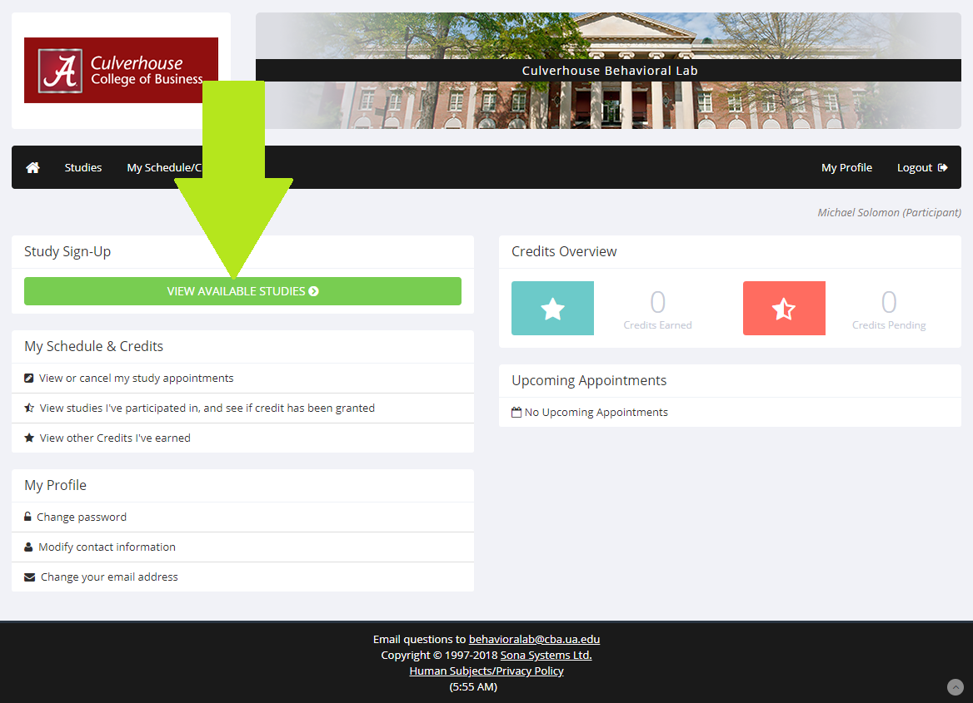

This will bring you to a list of available studies. Select the study that interests you to see available timeslots. 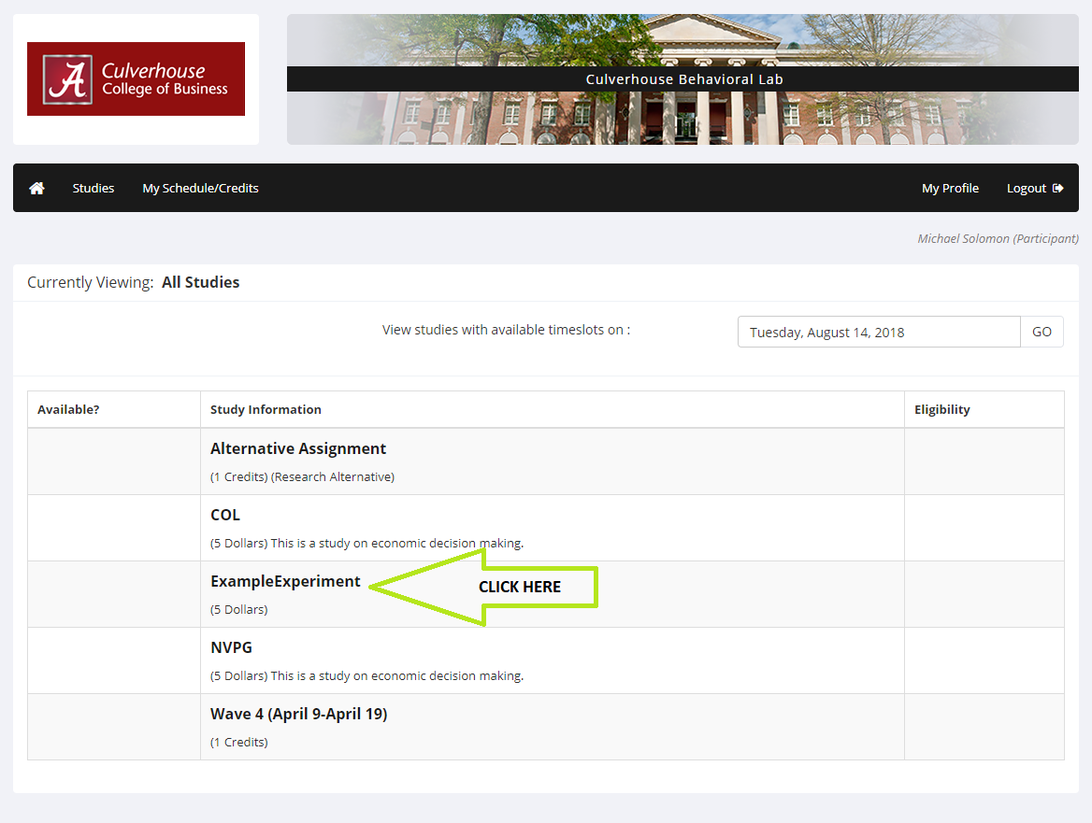

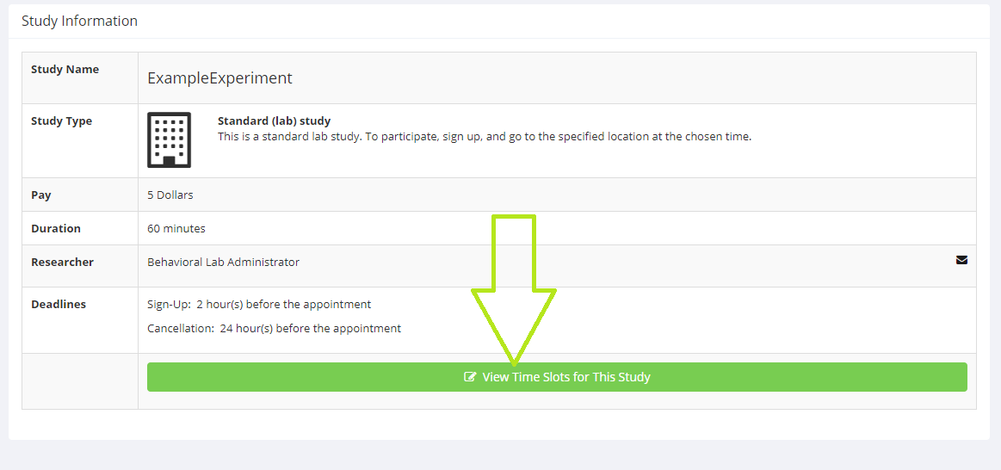
On this screen, select a time you will be available to participate. Please remember that you must be at the lab 5 minutes early. Also, pay special attention to how long the study will last. 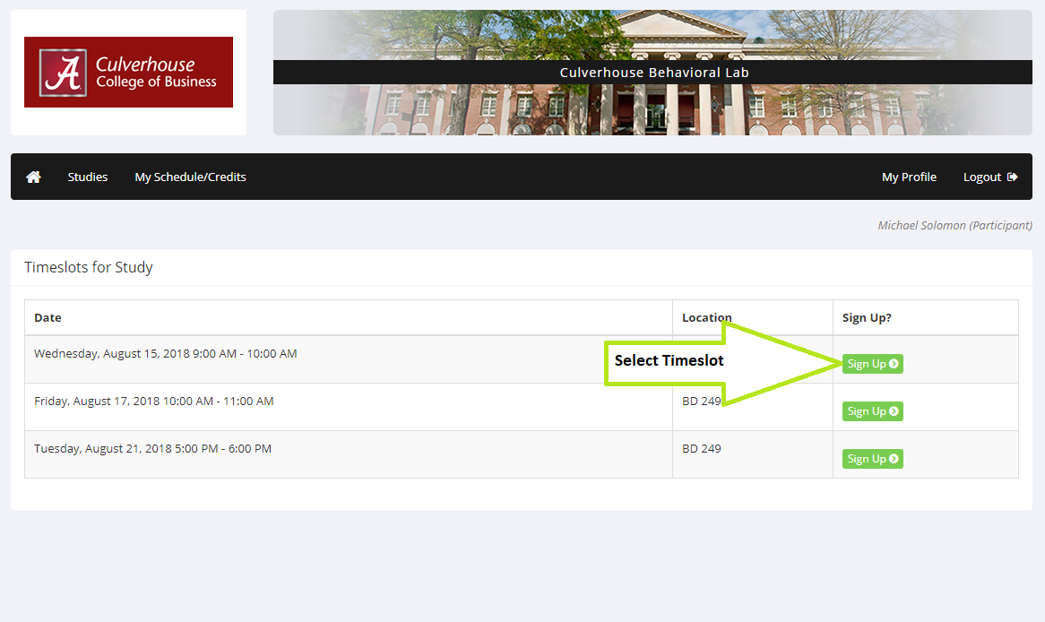

Here you will need to confirm that this is the time slot you want to sign up for. Click the sign up button.
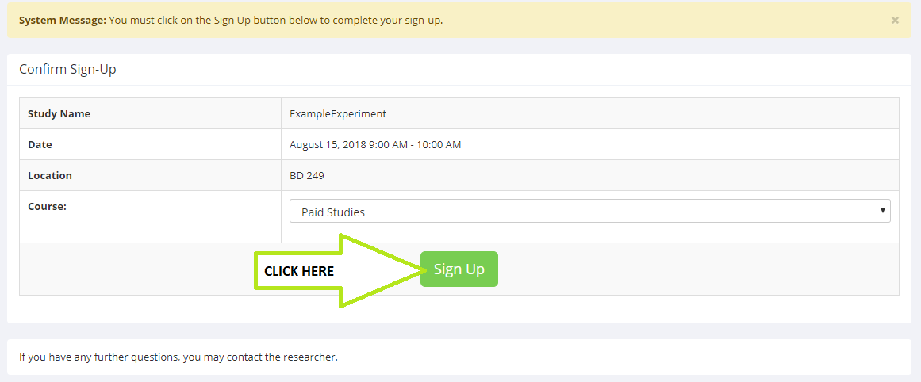

If you have signed up successfully, you will see a confirmation screen.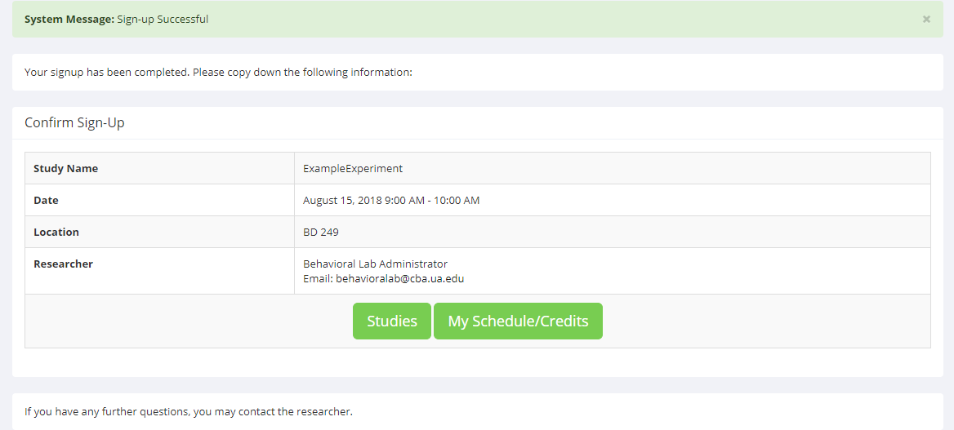

If you see this screen, then you are signed up. All you need to do is show up 5 minutes before the start time.

If you have any questions or concerns, contact TIDE Lab at behavioral_lab@cba.ua.edu.

